Marisol Santos
Manga Character Profile Dossier · BAN240

Course: BAN240 | Document Type: Character Sheet | Date: June 6, 2026
Character: Marisol Santos | Role: The Quiet Anchor | Prepared by: Stephen
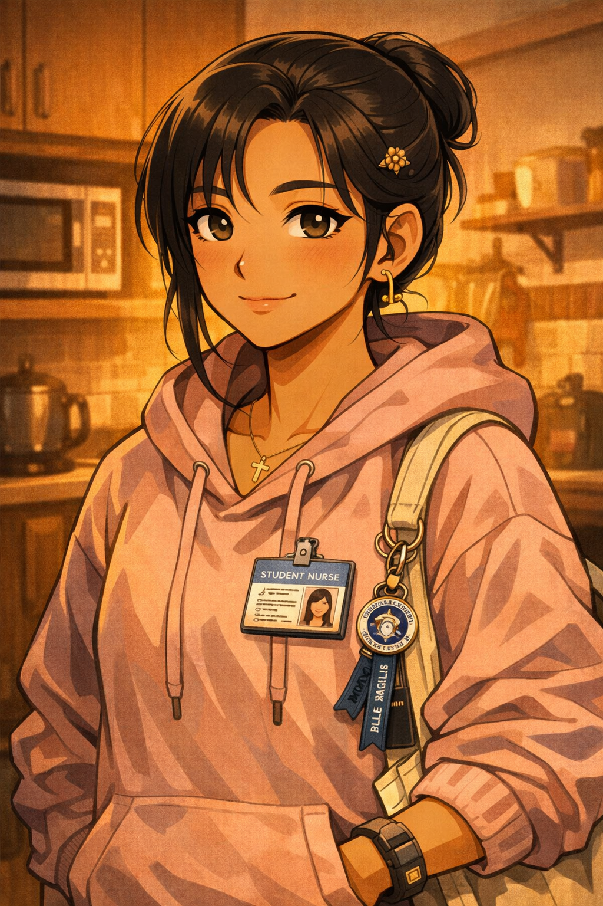
Section 01
Biographical Overview

Mari is a 21-year-old Filipina international student who carries the weight of her family's investment in her future with every decision she makes — and makes it look effortless. She is the eldest daughter, which in her household means something specific and unspoken: she is expected to succeed quietly, to not complain, and to send money home when she can, even when she barely has enough.
She came to Canada to study nursing because her mother is a nurse and because it was the clearest path her family could see from Manila to a stable future. She has never told anyone that what she actually wanted to study was literature.

"She is the character who holds the group together without anyone noticing — until she is gone for a week and everything quietly falls apart."
— Character Narrative Function Note

Her emotional intelligence is extraordinary and almost burdensome. She reads people with the same accuracy she applies to clinical assessment exercises, and she absorbs distress around her the way a sponge absorbs water — thoroughly, and without being asked. Her arc is about learning to put the sponge down.
Section 02
Demographics & Basic Information

Field | Detail
Full Name | Marisol Dela Cruz Santos
Goes By | Mari
Age | 21
Birthday | September 22
Gender | Female
Pronouns | She/Her
Ethnicity | Filipino (Tagalog-Bisaya family)
Hometown | Manila, Philippines (grew up in Quezon City)
Current City | Toronto, Ontario, Canada — Scarborough neighbourhood
Living Situation | Shares a 2-bedroom basement apartment in Scarborough with her cousin Ate Joanna (who arrived two years earlier) and one other Filipina nursing student; small, warm, perpetually smelling of adobo or sinigang
Immigration Status | International student visa
Languages | Filipino/Tagalog (native) · Cebuano (family dialect, understands more than she speaks) · English (fully fluent, with a slight Filipino lilt that softens under stress)
Occupation | Full-time undergraduate nursing student; occasional weekend shifts as a personal support worker aide (off the books, helps with tuition shortfall)
University | Toronto Metropolitan University (TMU)
Program | Nursing (BScN)
Year | 3rd Year

Section 03
Physical Appearance & Manga Portrait Description

Physical Profile

Attribute | Description
Height | 5'4"
Build | Slight but sturdy — the build of someone who has been on her feet for long shifts since she was seventeen; moves with quiet efficiency, no wasted motion
Hair | Long, dark brown-black, typically pulled into a neat bun or ponytail for clinical placements; worn loose on weekends, slightly wavy; a single small gold pin near the left temple — a gift from her lola
Eyes | Deep brown, calm and attentive — "I have already assessed the situation and I am deciding how to respond" energy; soft crinkle at the corners when she genuinely laughs
Skin Tone | Warm light-medium brown with golden undertones, a slight rose flush at the cheeks
Typical Outfit | On campus: scrubs or neat clinical wear from placement, worn with white rubber-soled sneakers she keeps spotless; off duty: oversized pastel hoodies, high-waisted jeans, small tote bag covered in lanyard pins from school events and one very worn Ateneo de Manila keychain
Accessories | Small gold cross necklace — always, never removed; simple hoop earrings; wears her student nurse ID clipped to her hoodie even on non-placement days out of habit

Manga Art Style Notes

◆ Artist Direction
• Stillness panels: Mari's most expressive moments are rendered in near-silence — a slight change in posture, a lowered gaze, a hand that stops mid-motion. The reader feels the weight before she speaks.
• The bun detail: Her hair is always drawn with one or two strands escaping at the temple — never perfectly neat. This is intentional; it is the only sign that she is tired.
• Warm light: Scenes in her apartment kitchen — cooking for the house — are always rendered with warm, low, amber light. It is the one space where she is allowed to be soft without an audience.
• Ate energy: When she shifts into eldest-daughter mode, her posture changes visibly — spine straighter, chin slightly up, voice a register lower. The manga uses this as a visual shorthand: readers learn to read the shift.
• The cross: Drawn with care in every panel it appears; it is not background detail. It is her anchor.
• Homesickness panels: Rendered as quiet close-ups — the sound of a familiar recipe, a FaceTime call where she talks about everything except how she is feeling. No dramatic effects. Stillness.

Section 04
Personality & Quirks

Mari is the person who checks on everyone and is not checked on nearly enough. This is partly because she does not invite it — she deflects personal questions with warm efficiency, answering with something true but not the thing she was actually asked.
- Eldest-daughter instinct is structural: she arrives early, she cleans up without being asked, she remembers everyone's dietary restrictions and food allergies without writing them down.
- Never asks for help directly; will say "I'm fine" until she physically cannot anymore — then she asks in a very small voice that surprises everyone who assumed she didn't need anything.
- Code-switches constantly between English and Tagalog, including mid-sentence; uses naman, kasi, ate/kuya honorifics with people she trusts, which functions as a form of intimacy.
- Laughs very easily at deadpan humour and is funnier than she lets on — she delivers punchlines quietly and then goes back to eating as if nothing happened.
- Has a specific relationship with food as love language: she brings tupperware to campus, she shares without being asked, she will feed you whether you are hungry or not.
- Maintains a prayer journal that she does not discuss; attends Sunday mass at a Filipino community church in Scarborough — this is the one hour per week that belongs entirely to her.
- Gets quietly upset when people mispronounce her name (it is Mah-ree-sol, not Mare-ee-sol) but does not correct them unless they are someone she likes.

◆ Character Note — The Weight She Carries
Mari carries the guilt of distance — from her mother, from her younger siblings, from the version of herself that wanted something else. She channels it into competence. Her competence is real and impressive and also a coping mechanism, and her arc is about someone who is very good at taking care of everyone finally learning to be taken care of.

Section 05
Hobbies & Interests

# | Hobby | Notes
1 | Cooking Filipino Food | Adobo, sinigang, kare-kare, pancit, arroz caldo — cooks for the household; cooking is decompression, care, and cultural preservation simultaneously
2 | Reading (Literary Fiction & Romance) | The thing she actually wanted to study; annotates novels in pencil; her most battered book is a Filipino edition of Lualhati Bautista's Bata, Bata… Pa'no Ka Ginawa?
3 | K-Drama & Filipino Drama | Watches for the emotional catharsis she does not allow herself in real life; has opinions about narrative structure; cries privately and thoroughly
4 | Journaling | Writes daily; mixes English, Tagalog, and occasionally Cebuano; the journal has a lock; no one has ever read it
5 | Nursing Skills Practice | Practices clinical skills in off-hours because she is terrified of making a mistake with a real patient; her sim lab time is self-scheduled
6 | Plant Care | Has six small plants on the apartment windowsill; speaks to them in Tagalog when she waters them; considers them hers even though the apartment is shared
7 | Group Chat Maintenance | Manages no fewer than four family and friend group chats across two time zones; this is labour she performs daily and considers non-negotiable

Section 06
Sports Profile

Category | Sport & Detail
Primary Sport (Fan) | Basketball — specifically the NBA (Toronto Raptors, adopted immediately upon arrival) and the PBA (Philippine Basketball Association) back home; will watch PBA highlights on her phone during lunch breaks
Primary Sport (Participatory) | Volleyball — played libero in high school in Manila; now plays occasional recreational games with the Filipino Student Association; her defensive instincts are still sharp
Secondary Sport (Fan) | Follows Philippine boxing (Manny Pacquiao's legacy is still a talking point in her household); knows more about the history of Philippine boxing than most people expect
Anime Sports Influence | Haikyu!! — understood it immediately as a story about how a team of people with different limitations becomes greater than any individual; applied its ensemble logic to how she thinks about nursing care teams

Section 07
Fandoms

Fandom | Description & Intensity
Toronto Raptors | Converted fan; follows out of solidarity with Arjun, who explained the 2019 championship to her in detail; now has genuine emotional investment
K-Drama Community | Deep fandom; has a ranked list of dramas; participates in fan discussions online under a pseudonym; considers this private
OPM (Original Pilipino Music) | Ben&Ben, IV of Spades, Unique Salonga — listens when homesick; the music carries the specific texture of Manila in a way nothing else does
BTS (Legacy Fandom) | Carried over from high school; listens to specific albums as comfort during hard shifts; does not discuss publicly
Filipino Cinema | Films by Brillante Mendoza, Lav Diaz, and John Lloyd Cruz-era rom-coms — she holds both the prestige and the popular simultaneously
Haikyu!! | Her primary anime fandom; has rewatched the entire series twice; the Karasuno team dynamic maps directly onto how she thinks about her cohort
Filipino Student Association (TMU) | Community, not a conventional fandom — it is her emotional infrastructure in Canada, the place where she can be tired without explanation

Section 08
Commute & Daily Life

The Commute

Leg | Detail
Home Base | Scarborough — near Warden Avenue corridor
Route | Walk to bus stop → TTC bus → Kennedy Station → Line 2 subway west → Dundas station → walk to TMU
Duration | ~55–70 minutes one way
Commute Mood | Earphones in, Filipino playlist or nursing podcast; uses the subway leg to review clinical notes on her phone; the bus ride home is for K-drama or silence, depending on the shift
Signature Move | Falls asleep on the subway approximately once a week; has missed her stop exactly three times; her body knows the journey better than her conscious mind does
Transit Pet Peeve | When someone sits directly beside her in an otherwise empty car — she will not move, but she will put both earbuds in immediately

On-Campus Routine
- Arrives 15 minutes early to every class, sits in the third row — close enough to hear clearly, far enough from the front to observe the room.
- Eats lunch alone on days after clinical placement — she needs the quiet to decompress; her friends have learned this and do not take it personally.
- Keeps a small laminated card of Filipino nursing terms in her lanyard pocket — a private translation aid she has never mentioned to a faculty member.
Weekly Rhythm

Time | Activity
Weekday mornings | Early bus, clinical placement or class; prayer in the first five minutes of the commute — eyes open, quiet, internal
Weekday afternoons | Campus study rooms; nursing skills lab; check-in text to her mother at 7pm Manila time (which is 6am Manila; her mother wakes for it)
Weekday evenings | Home, cook, journal, sleep earlier than anyone her age should have to
Saturday | PSW aide shift when needed; FSA events on alternating Saturdays
Sunday | Filipino community mass in Scarborough; groceries; FaceTime with her family in Manila — the one call where she lets herself be homesick out loud

Section 09
Character Role & Narrative Function

Mari is the quiet anchor of the ensemble — the person whose steadiness makes other characters' chaos feel safe rather than destabilizing. She is not the most visible character, but her absence would restructure every relationship in the group.
Narrative Arc
Her arc is the slow, necessary unlearning of eldest-daughter self-erasure. She has been so good at making herself smaller — quieter, needier-looking than she is, more fine than she actually feels — that her most powerful scenes are the ones where she finally does not.

"Her most powerful scene is not a breakdown. It is the moment she lets someone bring her food — and does not say she wasn't hungry."
— BAN240 Character Narrative Notes

Ensemble Role Summary

Function | How It Manifests
Quiet Anchor | Her steadiness allows others to be unstable; she is the emotional ballast of the group without calling herself that
Caretaker | Brings food, remembers details, shows up; care is her primary language and her primary liability
Cultural Grounding | Introduces Filipino culture through food, language, and ritual — never through explanation; the reader learns by watching
Internal Arc Carrier | The eldest-daughter weight is the slow burn of her story; her growth is measured in the moments she chooses herself

"She came to Canada to be a nurse. What she is quietly becoming is someone who has learned that she is also allowed to need things."
— BAN240 Character Narrative Notes

Marisol Santos — BAN240 Manga Character Sheet · Toronto Metropolitan University · Prepared June 6, 2026
Document prepared by Stephen · BAN240 Character Profile Dossier Series

